Untitled Party Game

Published By:

XYZ Corp

Developed By:



Revision: 0.0.1

# Document History

|  |  |  |  |
| --- | --- | --- | --- |
| **Ver** | **Date** | **Summary** | **Author(s)** |
| 0.0.1 | 7/1/2024 | Template Draft | Alit |
|  |  |  |  |

Document History

Game Summary

Target Platform(s)

Business Model

Game Overview

Theme / Setting / Genre

Core Gameplay Mechanics

Server / Online Mechanics

Push Notifications

Story and Gameplay

Story

Core Gameplay

Meta-Games

User Interface / Screens

Main Menu

Gameplay Screen

Premium Currency Store

Coins Store

Gear Shop

Settings Popup

Daily Reward Popup

Game Over Screen

Levels

Level Design Tools

First Time Experience

Economy

Asset List

Associated Documents

# 

# Game Summary

A quick summary of the game / high level big picture.

* Some Bullet Points with Unique Features
* And A Few More

## Target Platform(s)

* Modern iOS and Android tablets and phones.
* The game will be in portrait mode.

## Business Model

This will be a free to play game with micro-transactions and rewarded video ads.

# Game Overview

## Theme / Setting / Genre

Show some example images or similar games / movies / books / TV shows with similar themes.

## Core Gameplay Mechanics

Point to other games that this is similar to.

* Bullet points indicating what is new or different in your game vs. those ‘known’ games:

## Server / Online Mechanics

* Account With Cloud Save
* Weekly Leaderboard
* Server-Side Data / Settings
* Etc.

## Push Notifications

If any...

# Story and Gameplay

## Story

Once upon a time, in a universe far away…

Explain how the story will be told -- cut-scenes? A ‘talking head’?

## Core Gameplay

A description of the game ‘loop.’

A flowchart is nice:

## Meta-Games

Variables or systems that work such as upgrading characters, etc.

More flowcharts!

# User Interface / Screens

Wireframes of **every** screen or popup in the game and clear info on how they connect and lead to each other.

Numbering these sections makes them easy to find and you may even want to make a master flow-chart with ALL screens showing how each connects to the other.

## Main Menu

* Game Logo
* “Play Now” Button - Goes to 2. Gameplay Screen
* “Store” - Goes To 3. Premium Currency Store
* “Settings”
* “Credits”

## Gameplay Screen



## Premium Currency Store

You know what to do here!

## Coins Store

Maybe different from a premium store.

## Gear Shop

Lala.

## Settings Popup

Pop Ups too!

## Daily Reward Popup

Pop Ups too!

## Game Over Screen

And more!

# Levels

Details about how many levels.

How levels will vary.

An example of a beginner level.

An example of a complex level.

A graph of the level “curve” which is usually starting easy as the player learns the game, getting a bit more difficult until the player faces off against a nerve-wracking “boss fight” or “challenge gate”, then sawtooth down to a bit easier again to let players relax.

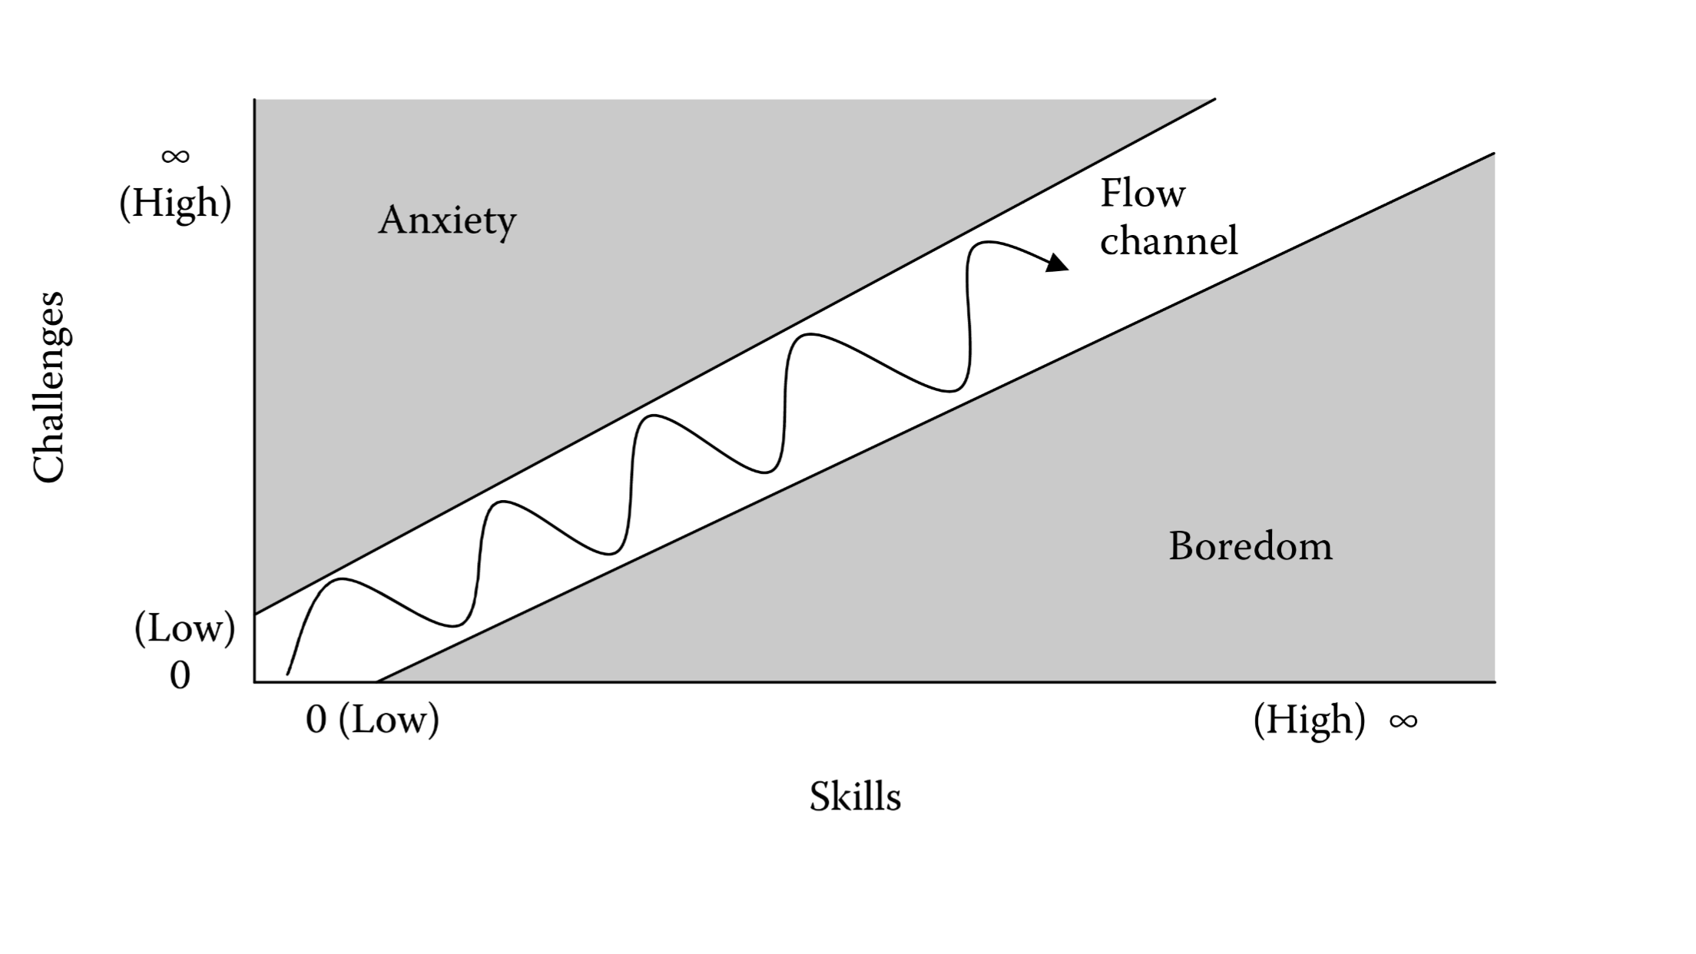

# Level Design Tools

For example, is a tool needed for a designer to create and play-test levels?

How does it work exactly?

# First Time Experience

Step by step.

Details of how a new player learns your game.

# Economy

Link to Spreadsheet with tabs for all economy details. Such as:

* Info about premium currency:

|  |  |
| --- | --- |
| **USD** | **Coins** |
| $0.99 | 100 |
| $4.99 | 550 |
| $9.99 | 1200 |
| $19.99 | 2500 |
| $29.99 | 4000 |

* Info about the soft currency.
* Info about experience points (XP).
* Info about leveling up.

|  |  |  |
| --- | --- | --- |
| **Level** | **Total Exp Required** | **Delta XP For Next Level** |
| 1 | 0 |  |
| 2 | 5,000 | 5,000 |
| 3 | 15,000 | 10,000 |

* Info about unlocking things based on level.
* Info about everything you can ‘buy’ in the store or in the game:

|  |  |  |  |  |  |
| --- | --- | --- | --- | --- | --- |
| **Item** | **Position in Shop** | **Currency** | **Level**  **Required** | **Shop Value in Premium Currency** | **Shop Value in $** |
| 2x Booster | 1 | premium currency | 2 | 70 | 0.47 |
| 3x Booster | 2 | premium currency | 4 | 400 | 2.50 |

* Info about any other stats for combat, hit points, upgrading, etc.

# Asset List

* Art
  + Note if 2D or 3D
  + If 3D Details on Textures and Poly Count
* Environment Art
  + All Associated Animations
* UI - Icons, Buttons, Pop Ups
* Game Objects
  + Buildings
  + Characters
  + Weapons
  + Tools
  + All Associated Animations
* Particle FX
* Sound Effects
* Music
* All Writing
  + Quest Scripts
  + Story ‘Screenplay’
* Level Design Documents

A big spreadsheet with columns and sections for each screen / major area is helpful:

|  |  |  |
| --- | --- | --- |
| **Category** | **WORLD MAP** | **Description** |
| Full Screen | Background | Background image that covers the whole scene |
| Icon | City 1 Icon | New York style |
| Icon | City 2 Icon | San Francisco style |
| Icon | City 3 Icon | Paris style |
| Sprite | Locked City | Big lock |
| Icon | Coming Soon | A banner that says ‘Coming Soon’ |
|  |  |  |
| **Category** | **ENVIRONMENT ASSETS** | **Description** |
| Full Screen | Sky Background | 2D image of sky |
| 3D | Rooftop | Roof shingles with chimneys, antenna, etc. |

# Associated Documents

* Full Asset List (Spreadsheet)
* Full Economy / System Design (Spreadsheet)
* Technical Design Document (TDD)
  + All Tools Used
  + Architecture Decisions
  + Cloud Hosting
  + Etc.
* Creative Design Document (CDD)
  + Mood Boards
  + Etc.
* Schedule (Spreadsheet)
  + A list of all milestones
  + What is in the milestone
  + Team to accomplish the milestone
  + Delivery date
* Budget (Spreadsheet)
  + IP / Brand License Costs
  + Software License Costs
  + Hardware Costs
  + Hosting Costs
  + Team Costs
    - Total
    - And Per Milestone
  + Marketing Costs